9.Experiment: AI-Assisted Features & Zia Analytics in Zoho Creator

Aim:
To explore and configure built-in artificial intelligence capabilities (Zia) and advanced analytics features within Zoho Creator for intelligent data querying, predictive forecasting, and automated insights.

Overview:
Zoho Creator integrates Zia (Zoho's conversational AI and analytics assistant) to empower low-code developers with natural language processing, automated chart creation, anomaly detection, and predictive analytics.

Feature / Capability | Functional Description in Zoho Creator
Zia Voice & Chat | Allows users to query application data and trigger reports via conversational commands.
Smart Analytics | Automatically suggests metrics, pivot tables, and visual charts based on dataset patterns.
Anomaly Detection | Flags irregular data entries, performance delays, or transaction spikes using machine learning.

Procedure:
- Enable Analytics & Zia: Open your Zoho Creator application workspace, navigate to the Analytics module, and ensure Zia AI assistant integration is active for your target data tables.
- Generating AI-Driven Dashboards: Use the natural language query prompt box to type commands like "Show total revenue grouped by month as a bar chart" or select Zia's automated dashboard recommendations.
- Configuring Predictors & Insights: Set up data prediction models to forecast future trends based on historical application records (e.g., project completion dates or order volumes).

Screenshots:

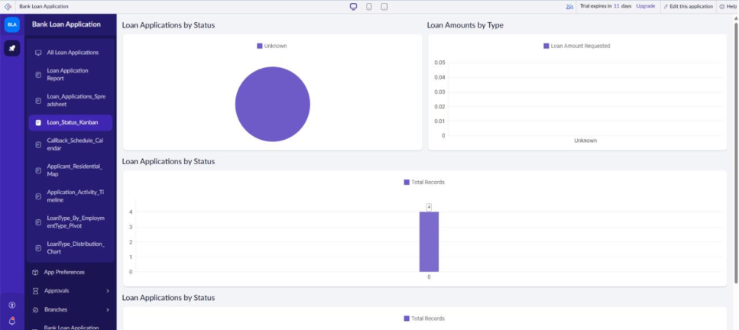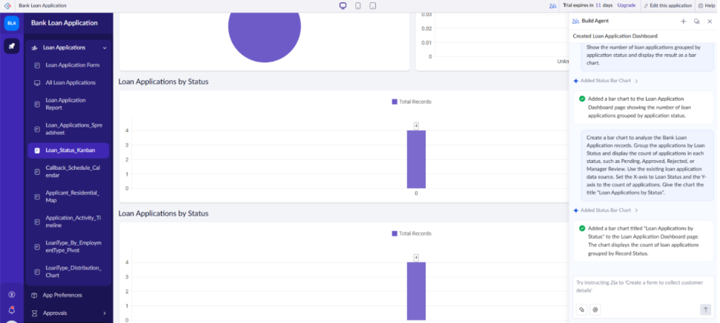

Result:
The experiment successfully demonstrated the integration of AI-driven analytics using Zia in Zoho Creator, proving its efficiency in delivering automated business intelligence and natural language data exploration without manual script coding.

